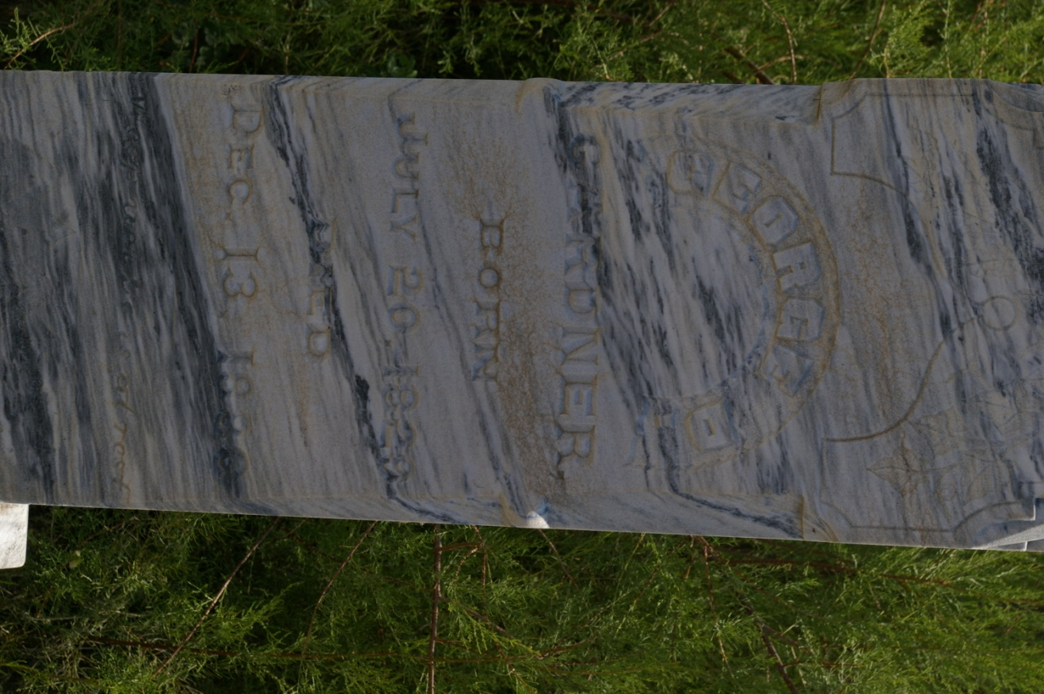

**Introducing New District Employees**

Mike Miller has been hired as shop mechanic. Robert Wolfe and Mike Boyce have joined our maintenance crew. We welcome them to the South Board of Control Staff.

**Computerized Water Program**

The new computerized water entry program has continued to work well. Remember you have the option to view your property water entries. You will need to contact the office for instruction, an activation pin and customer number for sign-in to your account. This is for viewing only. The web site is:

**www.southboardofcontrol.com**

**2021 Manager Notes**

As we all know by now, the Owyhee Reservoir did not adequately fill for the 2021 irrigation season. The allotment for New Gem and Ridgeview Districts has been reduced from 4 acre feet to 3 acre feet for this season. Water users that have property in both Old Gem and New Gem or Ridgeview cannot work their water together. If you have any questions about working water together, please contact the office. With a reduced allotment New Gem and Ridgeview water users will need to keep a close watch on their remaining allotment balance.

The board was able to hold the assessment to a decrease of .07 cents an acre in Gem and no change per acre in Ridgeview. For 2021 rates are $60.01 for Gem and $60.57 Ridgeview.

**Water Order Information**

Water orders for this year are back to calling the water office numbers (208)337-4141 and (208)337-3505 between 7 a.m. and 7:30 a.m. or by dropping off cards at the water office. Please only call your ditch rider cell for emergencies.

**Ditch Rider Changes**

Ride 21 is no longer Clark Maybon, Kenny Woods has moved over to this ride, and Adam Combs is now riding Kenny’s old Ride 26.

#21 Kenny Woods……250-6083

#22 Dave Bowman.......899-7581 #24 Andy Howard……869-1746

#25 Servando Zalazar...880-8187

#26 Adam Combs.…....880-9192



Manager: John Eells (208)337-8178

Water Master: Ryan Nash (208)412-2065

Administrative Office: (208)337-3760

P. O. Box 67, Homedale, ID 83628

[office@southboardofcontrol.com](mailto:office@southboardofcontrol.com)

South Board of Control

Newsletter

July 2021

**District Projects**

**Board Meeting Change**

Board meetings are now being held in our New Building Conference Room at 201 W Wyoming Ave, Homedale, ID. You can now attend meetings in person or online via “Zoom”. If you wish to attend via zoom, please call the main office for call-in information.

**Board Members**

**Gem District**

Rick Smith, Chair

Steve Clapier, Vice Chair

Dennis Turner

Ryan Criffield

Chris Landa

**Ridgeview District**

Bret Nielson, Chair

John Lax, Vice Chair

Mark Aman